***SHORTEST PATH ALGORITHMS***

* Dijkstra Algorithm

Algorithm: <https://cp-algorithms.com/graph/dijkstra.html>

Implementation:

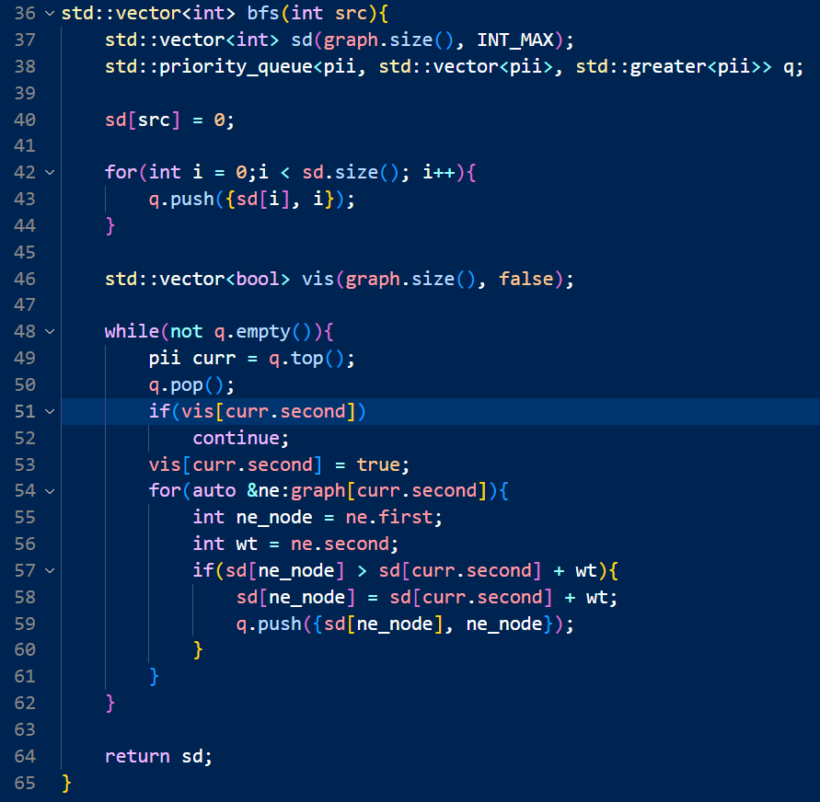

Proof:

D(s, u) = min distance computed by Dijkstra’s algorithm.